4 ANALYSE THE MALICIOUS NETWORK TRAFFIC USING WIRESHARK

AIM

To analyze malicious network traffic, investigate command-and-control (C2) activity, and identify indicators of compromise using packet capture analysis in the TryHackMe room “Carnage.”.

PROCEDURE

- Open the TryHackMe room “Carnage” and load the provided PCAP file in Wireshark.
- Study the suspicious HTTP, DNS, and SMTP traffic to identify malicious connections.
- Analyze downloaded files, domains, and Cobalt Strike C2 server activity.
- Complete the tasks and answer the questions based on the traffic investigation.

QUESTIONS

TASK 2 – Traffic Analysis

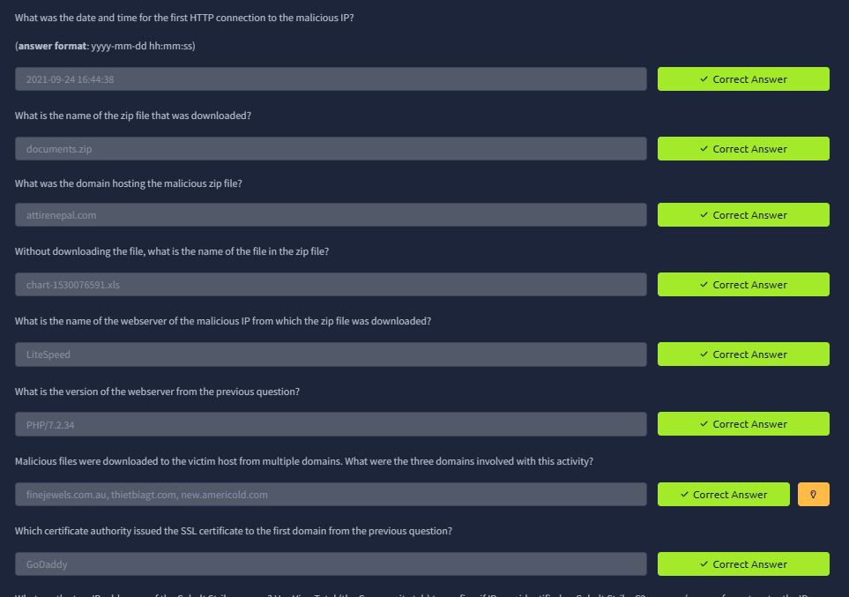

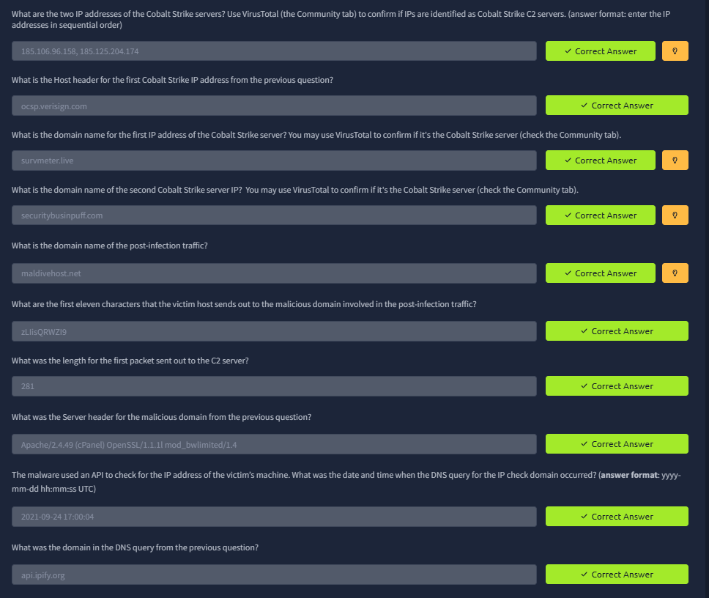
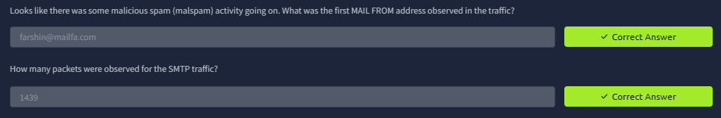

RESULT

Successfully learned how to investigate malicious traffic, detect C2 communication, and identify indicators of compromise using Wireshark and threat analysis techniques.

